Straatkunst – Urban Art – Urban Interventions

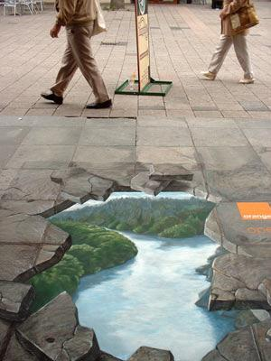
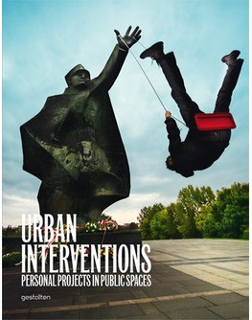
Slinkachu: project ‘Little People’
Slinkachu
28/m/UK
My 'Little People Project' started in 2006. It involves the remodelling and painting of miniature model train set characters, which I then place and leave on the street. It is both a street art installation project and a photography project. The street-based side of my work plays with the notion of surprise and I aim to encourage city-dwellers to be more aware of their surroundings. The scenes I set up, more evident through the photography, and the titles I give these scenes aim to reflect the loneliness and melancholy of living in a big city, almost being lost and overwhelmed. But underneath this, there is always some humour. I want people to be able to empathise with the tiny people in my works (citaat afkomstig van de site http://slinkachu.com/little-people ).
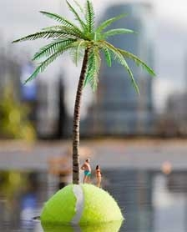
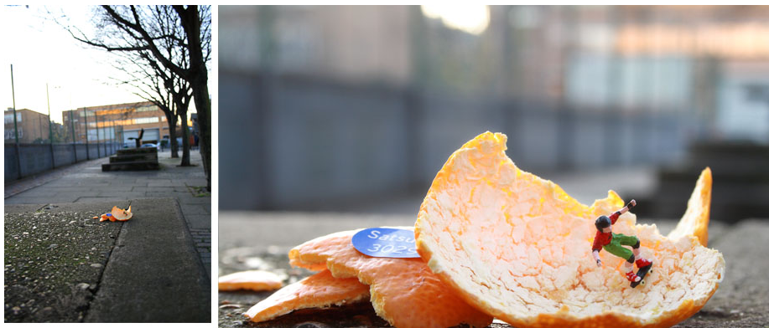
SpY
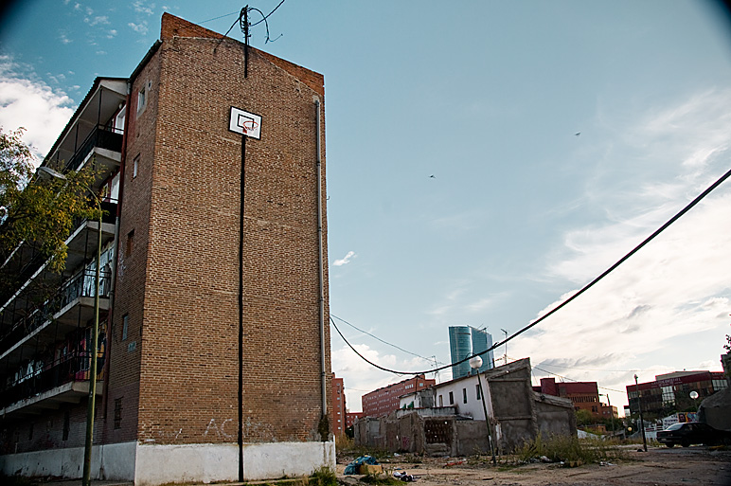
Julie Tremblay: project ‘Everything that happens’
Straatkunst

“De Spaanse kunstenaar SpY is de pionier in de discipline: hij plaatste al objecten in de stad in de hoogtijdagen van het graffiti-tijdperk, midden jaren tachtig. Zijn huidige werk is geniaal, zoals de laserkogels die hij uit een simpele straatpijl laat komen, waardoor een topsaai aanwijsteken ineens in een spannende ruimte-oorlog terecht lijkt gekomen. Van grote schoonheid is zijn bladerproject, waarbij hij herfstbladeren op basketbalveldjes op ingenieuze wijze bij elkaar harkt, in bijvoorbeeld een perfecte cirkel. De voorbijganger staat perplex, en dan, na een zucht wind is het kunstwerk weer verwaaid.”

Het citaat is van Robert van Gijssel en overgenomen uit de Volkskrant van 11-03-2011.
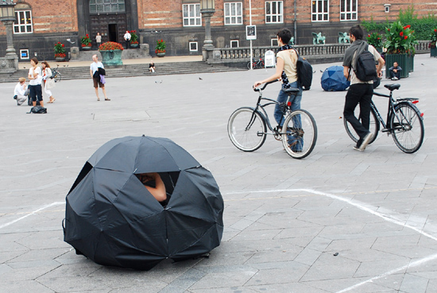
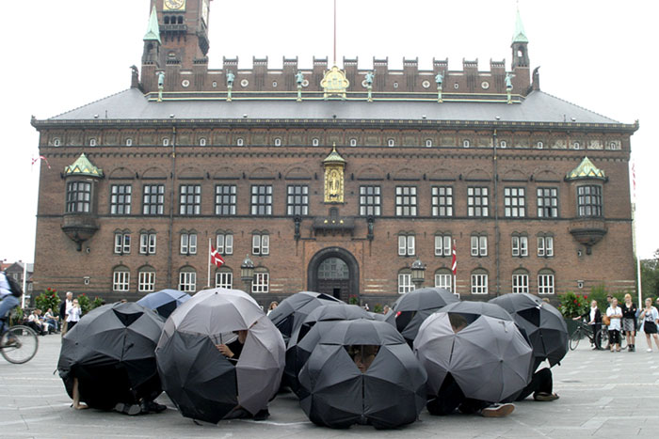
in samenwerking met Nana Francisca Schottländer (choreografie)

